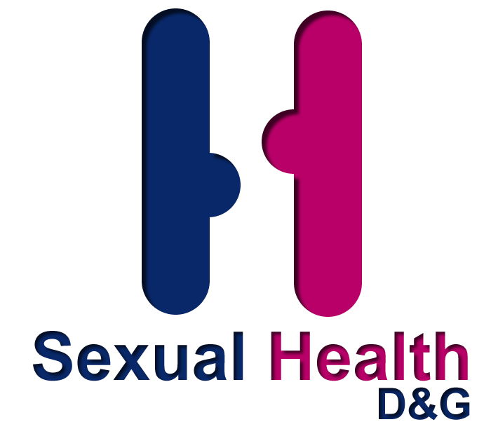
Sexual Health D&G currently offers 3 formal multiagency training days. On occasions we will be able to tailor individual training for agencies where they can pick and mix to suit their needs from the following packages. (Please contact dgsexualhealth@nhs.net)
TRAINING AVAILABLE FROM
SEXUAL HEALTH D&G
Bitesize Taster Sessions

These 2 hour sessions are aimed at those in the statutory and voluntary sectors who are interested and would like to receive an introductory insight into the issues and concepts around sexual health and services within the wider community. THESE SESSIONS ARE NOT FOR SERVICE USERS OR THE GENERAL PUBLIC.

MASH Tier 2 – Wake up to – Sexual Risk Taking behaviour

The day is aimed at those who have completed MASH Tier 1 and would like to receive an awareness /understanding of Sexual Exploitation and its components that can influence Sexual Risk taking behaviour.

- Sexual Exploitation
- Child Sexual Exploitation and indicators
- Social media,
- Pornography
- Issues of consent and Rape

Multi Agency Sexual Health Awareness Training (MASH) Tier 1

The day is aimed at those who are interested and would like to receive an introductory insight and understanding of sexual health. The topic of sexual health is often perceived as controversial and contentious and can raise complex issues. It is often portrayed in a negative manner with the emphasis on underage pregnancies and high rates of sexually transmitted infections (STIs). It is an aspect of health that affects us all throughout our lives and requires to be viewed in a positive way thus enhancing our overall health and wellbeing. The day will cover the following issues:
- Risk Taking Behaviour & Self Esteem
- Confidentiality & Legal Issues
- Contraception & Condoms
- LGBT Issues
- Sexually Transmitted Infections(STI)
C4U ‘C’ Card Training

For agencies wishing to be involved in the C Card scheme, staff should attend MASH 1 and then receive a tutorial / update on the paperwork involved

